|  |  |
| --- | --- |
| **ADEV Image Correlation** | **2016-2017** |
| **Tim McDaniel**  **Dustin George**  **Drew Maione** | **Sponsored by**  **https://lh6.googleusercontent.com/MDjqszAwrVpDqF3solBLLV6UkoT5-gl-Pf1IojnEQ8zz9ccShE0DmyKaPprDtLpCGW_wRFYehc53gkeNwYssA7TEFK0vKj66PsvDWCJKg6ZhPuj4Z5L2kdBUfMBZTYWm0brupeD7** |

**Objective**

The client for our senior design project is ADEV Automation, a robotics startup company that is developing a robot capable of navigating a strawberry field and picking strawberries using a cutter arm. We were tasked by ADEV to correlate the images generated by three cameras; two webcams and a depth camera. In other words, our project was to give a robot depth perception. ADEV wanted to be able to select a specific pixel in an image and be told the location of the image in the pixel relative to the robot arm. ADEV also needed a mount to hold their cameras on the end of the robot’s arm.

**Cameras**

Our project uses three cameras.  The first is an infrared time-of-flight camera from PMD that measures the amount of time it takes for infrared light to “echo” off of its surroundings.  We used this camera in this project to find distance readings from our sensor’s location to any point of interest in the area.  The second and third cameras are standard RGB webcams.  With the three of them arranged in a line, we are able to select a pixel in one of the webcams and then have the program calculate the location and distance to that pixel relative to the depth camera.

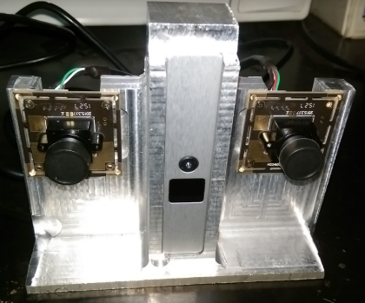

Correlation

C++ to access depth camera

Main project and GUI is in Python

Webcam calibration

Use trig to correlate

Describe GUI interaction + storage

UML diagram

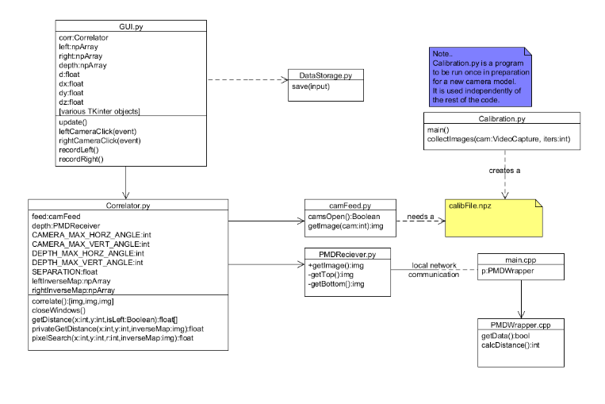

Mount

|  |  |
| --- | --- |
| https://docs.google.com/drawings/d/s1IySHhxA33ZA7Xp2-4wSVw/image?w=294&h=242&rev=221&ac=1 | https://lh3.googleusercontent.com/2JXZQERSZLVTyl2TD-7H74_3qbjV_fhclOSIODmxL-wmresEcDtlIx-OyZmLdi7TPNmA06dmONDhSoe6t6bt7HPZLmrTdfCtesOvl0GWnIPyXQKEYm6pFlG2kopx7pPsKs5aEdPS |

**Needs**

·       Software must correlate the webcam’s pixels to each depth camera pixel.

·       Software must return x, y and z displacement values relative to cameras.

·       The mount must weigh 0.5 lbs or less in order for the robot arm to carry it.

·       The mount must be able to dissipate the heat from the depth camera.

**Evidence**

**Software must correlate the webcam’s pixels to each depth camera pixel.**

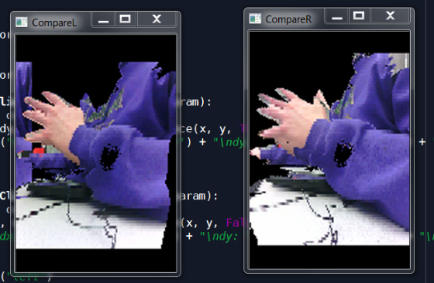

This is an image of the correlated depth and webcam images with the left and right webcams corresponding to the left and right images above. The black space in the background are pixels that were out of the depth camera’s range.

**Software must return x, y and z displacement values relative to cameras.**

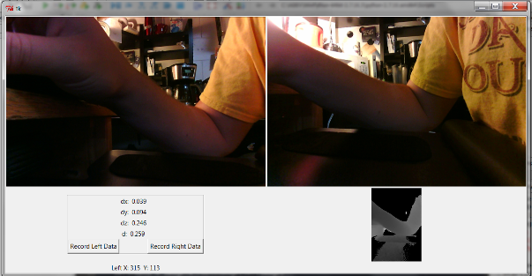

The GUI we designed for this software is shown above. The left and right color images represent the left and right webcams and, when these images are clicked on, the software returns the location and distance of the pixel selected relative to the depth camera. These values are returned in the bottom left-hand corner as the dx, dy, dz, and d values.

**The mount must weigh 0.5 lbs or less in order for the robot arm to carry it.**

We were able to reduce the weight of the mount to 0.69 lbs which ADEV stated as satisfactory. We also informed ADEV that, if in the future there was a need to reduce the weight of the mount, there was still material that could be removed.

**The mount must be able to dissipate the heat from the depth camera.**

When attached to the aluminum mount the depth camera shows a temperature of 80.33℉. However, when removed from the mount, the temperature very quickly increases to 116℉.

ABET Report – ADEV Automation

**ABET criterion a - an ability to apply knowledge of mathematics, science, and engineering**

Our project required the development of a three camera mount system and software that used these cameras to provide a robot with stereovision. In order to do this we had to develop a heat transfer model for the depth camera and choose a material to adequately dissipate heat from said camera. The milling of the mount required a design utilizing tight tolerances and both knowledge in the use of a conventional mill or CNC mill. The software we designed for the cameras required a strong understanding of Python and image recognition. In addition, the process by which the program calculates the location and distance of the pixels primarily uses geometry.

**ABET criterion c - an ability to design a system, component, or process to meet desired needs within realistic constraints such as economic, environmental, social, political, ethical, health and safety, manufacturability, and sustainability**

**In order to satisfy criterion c, students will document the following:**

**1.  An understanding of the problem.**

**Objective**

The client for our senior design project is ADEV Automation, a robotics startup company that is developing a robot capable of navigating a strawberry field and picking strawberries using a cutter arm. We were tasked by ADEV to correlate the images generated by three cameras; two webcams and a depth camera. In other words, our project was to give a robot depth perception. ADEV wanted to be able to select a specific pixel in an image and be told the location of the image in the pixel relative to the robot arm. ADEV also needed a mount to hold their cameras on the end of the robot’s arm.

Cameras

Our project uses three cameras.  The first is an infrared time-of-flight camera from PMD that measures the amount of time it takes for infrared light to “echo” off of its surroundings.  We used this camera in this project to find distance readings from our sensor’s location to any point of interest in the area.  The second and third cameras are standard RGB webcams.  With the three of them arranged in a line, we are able to select a pixel in one of the webcams and then have the program calculate the location and distance to that pixel relative to the depth camera.

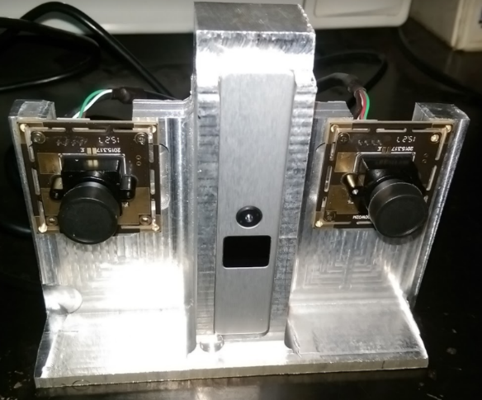

**Needs**

·       Software must correlate the webcam’s pixels to each depth camera pixel.

·       Software must return x, y and z displacement values relative to cameras.

·       The mount must weigh 0.5 lbs or less in order for the robot arm to carry it.

·       The mount must be able to dissipate the heat from the depth camera.

Correlation

C++ to access depth camera

Main project and GUI is in Python

Webcam calibration

Use trig to correlate

Describe GUI interaction + storage

**2. A detailed design**

UML diagram

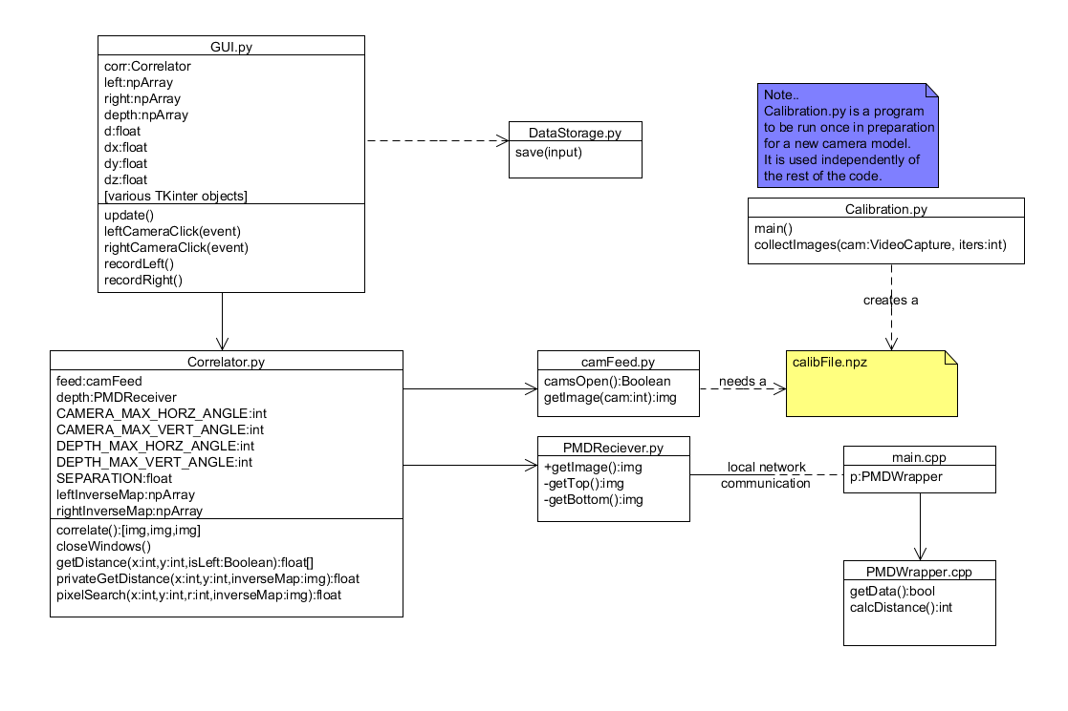

Mount

|  |  |
| --- | --- |
| https://docs.google.com/drawings/u/0/d/shMt_jFjYmzO0JiN5L0NZHg/image?w=250&h=206&rev=1&ac=1 |  |

**3. A Prototype of the design.**

|  |  |
| --- | --- |
| https://lh6.googleusercontent.com/g1Pg87gUhwQYX-9mfB8n1VEvLXIrP6jVO7N9OazdwsDWcjQ05eOnY_XOLtt1NmNztfj-SMoDs__GqpSDWYqzwFu89OOsCHtCAOo0y4wB167_-PAotW6DjQnH6gjMCjQIP2ENNZdB | Pictured to the left is our final prototype made with the CNC Mill. The cuts made by the mill are perfectly symmetrical. |

**4. Test and refine the implementation until the product or process design specifications are met or exceeded**

**Software must correlate the webcam’s pixels to each depth camera pixel.**

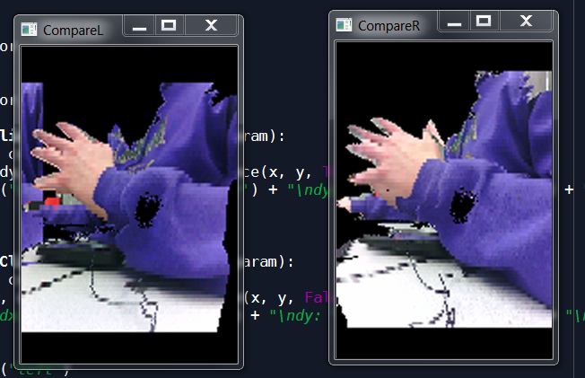

This is an image of the correlated depth and webcam images with the left and right webcams corresponding to the left and right images above. The black space in the background are pixels that were out of the depth camera’s range.

**Software must return x, y and z displacement values relative to cameras.**

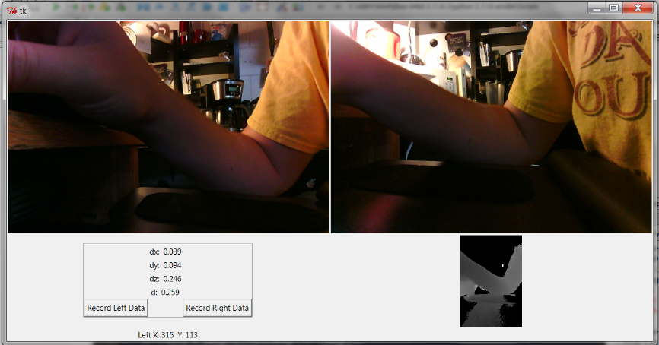

The GUI we designed for this software is shown above. The left and right color images represent the left and right webcams and, when these images are clicked on, the software returns the location and distance of the pixel selected relative to the depth camera. These values are returned in the bottom left-hand corner as the dx, dy, dz, and d values.

**The mount must weigh 0.5 lbs or less in order for the robot arm to carry it.**

We were able to reduce the weight of the mount to 0.69 lbs which ADEV stated as satisfactory. We also informed ADEV that, if in the future there was a need to reduce the weight of the mount, there was still material that could be removed.

**The mount must be able to dissipate the heat from the depth camera.**

When attached to the aluminum mount the depth camera shows a temperature of 80.33℉. However, when removed from the mount, the temperature very quickly increases to 116℉.